THE FRANK DEMARIS VOLUNTEER SPIRIT AWARD application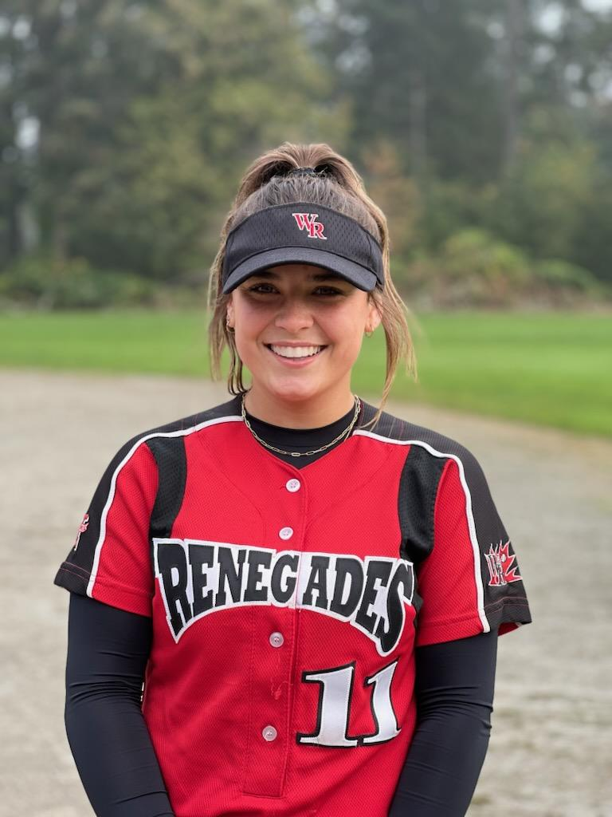

Dear Frank Damaris Volunteer Spirit Award Committee,

I am writing to express my interest in the Frank Damaris Volunteer Spirit Award Committee scholarship and outline some of my leadership accomplishments.

Over the past five years, I have been a proud member of the White Rock Renegades 2006 team. This sport has taught me work ethic, dedication, leadership, teamwork, and adaptability on and off the field. This team has taught me how to adapt to diversity and stick together no matter what obstacles are presented. It has also taught me how to apply these valuable characteristics to other aspects of my life.

My whole life, I have wanted to make a positive difference in other people's lives. I started out doing this by working extremely hard at practices and games, cheering everyone on, and setting big goals so I could become good enough to be a leader on and off the field. To be the best team player I could be.

*While this has been very rewarding, I knew I wanted to do more. I wanted to do something that was even more impactful outside of my life circle.*

After much continuous brainstorming about how to accomplish this, it finally came to me. This idea quickly became one of my most significant accomplishments and contributions to others, which was very fulfilling.

***I set a challenge and a goal for myself to raise money for the children's hospital*.**

***I created, organized, and ran a 24km run in 24 hours solo, raising $1,750 for B.C. Children's Hospital.***

*My inspiration:* When I was five years old, I was brought to Children's Hospital with a severe lump in my neck. I couldn't sleep or move my upper body, and I was very sick. I remember going and being very scared when I was told I was going to have to sleep overnight at the hospital and be in quarantine until they could find out what it was.

The first night, I was scared. The hospital accommodated me to have a big enough bed so my parents could sleep in the room with me. It helped make me feel less scared and it made a world of difference. The following day, we were informed I would have to spend many more nights there until they could find everything out and fully treat me. Once they diagnosed me with a lymph node infection and I was put on medication through IV and more, after some time passed, I was able to have enough energy to play in the playroom. Every day, over my 13 days there, I would play in that playroom for endless hours with my parents, sister and grandparents. It made my visit a lot easier, it made me feel safer, and it really helped me pass the time.

Throughout my life, I have always reflected on this time and experience with gratitude. I am very grateful that I had the care required to heal me and not get worse, as well as the playroom space. This experience and the genuine support and care I felt from the staff there are hard to express in words. I knew in my heart that one day, I would give back.

When I came up with my fundraising Idea, I knew the money would have to go to the children's hospital.

How I executed my fundraising plan at first by;

* By setting up a GoFundMe profile
* I Advertised on Instagram & Facebook ( I made separate accounts so that people could be updated and be more involved) and asked others to share
* I was interviewed by the local radio station, and they made announcements for me leading up to and through the event.
* I announced it at my school through media, the radio and talking to classes.
* I spread the word to everyone I encountered.

On the first day, I received nearly $500 in donations from family and friends. I was scared no one else would donate after that; however, when I began to share my account and my story, I started to get others ( outside of my circle’s) attention. I started to receive many more donations every day. I was over the moon when I made $500, but that soon turned into $1000, then $1200, and then $1500. I could not believe that I had not even run my 24 hours yet, but I already had $1500 in donations.

The day finally came when I set out to run. I had a plan and stuck to it so I could complete my goal. I would run 1km, then wait fifty-five minutes and then run my next 1 km. I did this for a whole twenty-four hours. By the very end, I had made $1800 in donations.

The feeling I felt inside was overwhelming; I could not believe that my idea and goal came together and that I, with the help of others, was able to give back to the hospital after everything they did for me. I knew that this would make a BIG difference for many more children for many more years.

Through this experience, I learned about my strengths, the support of others who I did not know, and the support of my family and friends. It proved to me my capabilities when I put my mind to something. **Most importantly, I learned how amazing it felt to give and work hard to give back.**

I carry those twenty-four hours with me every day, not because they were hard but rather because I now know that I have what it takes to make a difference in others' lives. I can apply this to any aspect of my life, including school, softball, and volunteering in and outside of my community. I hope to one day do something even larger than this, making another positive impact in many people's lives.

*My history with leadership*: I have taken leadership classes every year from the start of middle school until the end of high school. I know what it takes to be a leader, and I strive to be a positive leader every day.

I take great pride in being authentic and following my passions. This is why I have volunteered with my school and multiple other local charities, including, but not the only organizations, The Gleaners, Big Red Foundation, and the Christmas Bureau. I want to continue to use my spare time to help others in small and in significant ways to be myself with setting goals to create an impact in everything I do.

*Over the past four years,* I have been a part of Yale Secondary’s leadership class. In this class, I have been taught the value of true originality, generosity, kindness, hard work and, of course, leadership. As the majority of the assignments are to help and give to the school and community, you get to decide how you want to do this. This class has given me so many opportunities to make a difference, and I feel as though I made a significant contribution to my community and school by being a part of this class of leaders. My many hours volunteering at Gleaners, Special Olympics softball, The Christmas Bureau, Big Red Mental Health Society, Canada Cup and more organizations help demonstrate my commitment to my community and other communities outside of mine.

On top of community events, I also spent a large amount of my time before and after school helping set up events like Live to Give, Sports Banquets, School Breakfasts, helping host The Yale Idol and other fun events. Web leading demonstrates my contribution to my school. All of these events allowed me to step outside of my comfort zone, meet new people, and become very involved in my community and school.

When I hosted the Yale Idol event in grade eleven, I had to organize the stage setup, create posters, make announcements on our school's social media, and host the contestants competing to win. These events are just some small examples of the things I did and learned with my leadership in the school and community. Yale is one of the most positive, loving, and connected schools in and outside of its community.

In Grade 9, I received the “Yale Secondary Top Grade 9 Leadership Award” trophy. This was very unexpected but so impactful. While I did not need an award to give to others, it was nice at such a young age to be recognized in many different ways for volunteering and making a difference in others' lives over and above the obvious of just the overall feeling of “goodness.”

I know I will always continue to find ways to give, help others, and make a difference in ways that are considered normal and in ways outside of our everyday lives.

Thank you for considering my application. I appreciate you taking the time to read my story and my supporting letters and documents to help you identify my overall character.

Makaila Schneider